[SAMPLE ANNOUNCEMENT]

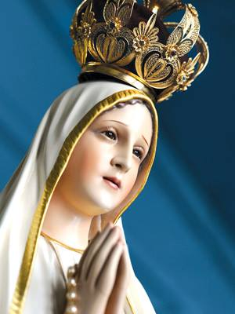
The world-famous International Pilgrim Virgin Statue, which has been traveling for 75 years, will be at our parish Tuesday, Oct. 18 (List schedule details).

After being blessed by the Bishop of Leiria-Fatima, on October 13, 1947, the statue left Fatima and was flown to America to begin its tours. The bishop prayed that Our Lady’s presence would travel with it wherever she went. It was blessed again in 1952 by Pope Pius XII, who had crowned the original statue in Fatima as Queen of the World just a few years earlier.

The mission of the Pilgrim Virgin Statue of Fatima is to bring the message of Fatima—the Peace Plan from Heaven—to a world in need. Our Lord told Sister Lucia, the oldest of the three seers at Fatima, that he had entrusted the peace of the world to the Immaculate Heart.
The International Pilgrim Virgin Statue has visited more than 100 countries, bringing Mary's powerful message of salvation and hope to millions. Countless favors and graces have been reported wherever the Virgin Statue has traveled.
We hope you will come and experience the blessings of Our Lady during this special statue visitation, sponsored by the World Apostolate of Fatima, USA – Our Lady’s Blue Army.

Prayer to Our Lady of Fatima for our Nation
O Queen of the Rosary, Sweet Virgin of Fatima, who has deigned to
appear in the land of Portugal, we beg you to watch over our dear homeland
and assure its moral and spiritual revival.
Bring back peace to all the nations of the world so that all,
our own nation in particular, may be happy to call you their Queen
and the Queen of Peace. Amen.
Our Lady of the Rosary, pray for our country.
Our Lady of Fatima, obtain for all humanity a lasting peace.

Say “Yes” to Our Lady!
www.fatimatourforpeace.com
www.bluearmy.com

